

FACULTY OF INFORMATION COMMUNICATION AND TECHNOLOGY

PROG 102 – PRINCIPLES OF SOFTWARE ENGINEERING

Title: FINAL PROJECT
Issue Date: WEEK 2
Due Date: WEEK 4
Lecturer/Examiner: Mr.Santigie Kamara
Class: BSEM 1201F
Semester: 2/1
Academic Honesty Policy Statement
I/we, hereby attest that contents of this attachment are my own work. Referenced works, articles, art, programs, papers or parts thereof are acknowledged at the end of this paper. This includes data excerpted from CD-ROMs, the Internet, other private networks, and other people’s disk of the computer system.

Student’s Signature : Date: 5/12/25
NO: | NAME SURNAME ID SIGN
1 | SHARON M. | KOROMA | 905006201
2 | ABDUL AZIZ | SESAY | 905005987
3 | GIBRIL | BANGURA | 905005708

LECTURER’S COMMMENTS/GRADE: |  | for office use only upon receive  Remark  DATE :  TIME :  RECEVER’S NAME :

Table of Contents
1. Introduction ............................................................. 3
2. Software Development Life Cycle (SDLC) ................................ 4
3. System Architecture Design ............................................. 7
4. Prototype Development (UI/UX) .......................................... 9
5. Git & GitHub Integration .............................................. 11
6. Project Management Plan ............................................... 12
7. License, Design Quality & SDG Relevance ............................... 14
8. Documentation & Conclusion ............................................ 16
9. References ............................................................ 17

1. Introduction

1.1 Background
At Limkokwing University of Creative Technology, Sierra Leone Campus, academic records — including coursework grades, semester results, and final transcripts — are still largely managed through manual and paper-based processes. At the end of every semester, lecturers compile grades and submit them to the academic registry, which then manually prepares and prints transcripts for students. This process is time-consuming, prone to human error, and creates delays for students who need official transcripts for scholarships, job applications, or further studies.
Students currently have limited visibility into their academic performance throughout the semester. They typically only see consolidated results at the end of each term, with no real-time access to individual coursework grades, attendance records, or course materials shared by lecturers.

1.2 Problem Statement
The core problem this project addresses is the lack of a centralized, digital academic records system at Limkokwing University Sierra Leone that allows lecturers to upload grades electronically, students to access their results and transcripts in real time, and the academic registry to generate official transcripts without manual compilation. Specifically:
- Lecturers must manually compile and print results at the end of every semester, which is time-consuming and repetitive.
- Students have no real-time access to their grades, GPA, or attendance during the semester.
- The academic registry spends significant staff time and printing resources generating transcripts on request.
- There is no centralized digital repository for lecturers to share course materials with students.
- Errors in manually transcribed results can lead to disputes and delays in releasing official transcripts.

1.3 Proposed Solution: Limko Wi Skul
Limko Wi Skul (meaning "Our School" in Krio, with a tagline of "Awi Skul, Awi Rezult" — Our School, Our Results) is a proposed digital academic portal designed specifically for Limkokwing University Sierra Leone. The system allows lecturers to upload grades and course materials directly into the system, automatically calculates GPA and CGPA, and generates official digital transcripts that students can view and download as PDF documents — eliminating the need for manual compilation and printing at the end of each semester.
As a Digital Public Good, Limko Wi Skul is built using open-source technologies and released under an open license, making it freely available for adoption and adaptation by other tertiary institutions across Sierra Leone facing similar challenges.

1.4 SDG Alignment
Limko Wi Skul is primarily aligned with United Nations Sustainable Development Goal 4: Quality Education, which aims to ensure inclusive and equitable quality education and promote lifelong learning opportunities for all. It also contributes to SDG 9: Industry, Innovation and Infrastructure, by modernizing the academic infrastructure of a tertiary institution. Specific contributions include:
- SDG Target 4.3: Ensure equal access for all to affordable and quality technical, vocational and tertiary education, by improving the efficiency and transparency of academic record management.
- SDG Target 4.4: Increase the number of youth and adults with relevant skills, including technical and vocational skills, for employment — by exposing students and staff to a modern digital academic system.
- SDG Target 9.c: Significantly increase access to information and communications technology, by digitizing previously paper-based academic processes.

1.5 System Users
The system is designed to serve four categories of users at Limkokwing University Sierra Leone:
User Role | Primary Responsibilities
Student | View course grades, GPA/CGPA, download official transcript PDF, access course materials, check attendance records
Lecturer | Upload coursework and exam grades per course/semester, upload lecture materials and notes, mark student attendance
Academic Registry (Admin) | Manage student records and programs, review and approve grade submissions, generate and certify official transcripts, manage courses and semesters
HOD / Dean | View department-wide academic performance reports, monitor lecturer grade submission status, generate analytics for decision-making

2. Software Development Life Cycle (SDLC)

2.1 Chosen SDLC Model: Agile (Scrum Framework)
Limko Wi Skul will be developed using the Agile SDLC model, specifically the Scrum framework. Agile was chosen because the system involves multiple distinct user groups — students, lecturers, registry staff, and deans — each with different requirements that are best refined through iterative development and continuous feedback. Agile's short development cycles also allow the team to prioritize the most critical features, such as grade upload and transcript generation, early in the project.
The Agile Scrum framework organizes work into short development cycles called Sprints, each lasting two weeks. At the end of each sprint, a working increment of the software is delivered and reviewed with stakeholders, including sample lecturers and students from Limkokwing University.

2.2 Justification for Agile Over Waterfall
The Waterfall model follows a strict sequential process and does not accommodate changes once a phase is completed. For an academic records system, requirements such as the exact format of the transcript, grading scale, and GPA calculation formula may need refinement after consultation with the academic registry. Agile's iterative approach allows these details to be adjusted without restarting the entire development process, making it the more suitable choice for this project.

2.3 SDLC Phases for Limko Wi Skul

Phase 1: Planning
In this phase, the project team defines the scope, objectives, timeline, and resources required to develop Limko Wi Skul. Key activities include:
- Identifying stakeholders: students, lecturers, the academic registry, heads of department, and university management.
- Defining the project vision: to digitize grade management and transcript generation at Limkokwing University Sierra Leone.
- Developing the initial Product Backlog — a prioritized list of features such as grade upload, GPA calculation, and transcript generation.
- Creating a Project Charter outlining deliverables, milestones, and team responsibilities.
- Risk identification, such as data accuracy of historical academic records and resistance to change from staff accustomed to manual processes.

Phase 2: Requirements Analysis
This phase involves gathering and documenting all functional and non-functional requirements of the system through consultations with lecturers, students, and registry staff. Key outputs include:
- Functional Requirements: User login by role, grade entry per course and semester, automatic GPA/CGPA calculation, transcript PDF generation, course material upload and download, attendance marking.
- Non-Functional Requirements: The system must be accessible via web browser on both desktop and mobile, support role-based access control, ensure grade data integrity through validation, and generate transcripts in a format consistent with the university's official template.
- Use Case documentation capturing interactions such as 'Lecturer uploads grades', 'Student downloads transcript', and 'Registry approves results'.
- User stories written in Agile format: As a [role], I want to [action] so that [benefit].

Phase 3: System Design
Using the requirements gathered, the team designs the system architecture, database schema, and user interface. This phase produces:
- System Architecture Diagram showing how the frontend, backend, database, and PDF generation service interact.
- Entity Relationship Diagram (ERD) covering students, courses, grades, semesters, and transcripts.
- UML Use Case Diagram, Class Diagram, and Sequence Diagram for key processes such as grade submission and transcript generation.
- Wireframes and high-fidelity Figma prototypes for all key screens.
- Selection of technology stack: React.js (Frontend), Node.js with Express (Backend), MySQL (Database), and a PDF generation library for transcripts.

Phase 4: Implementation (Development)
The actual coding of Limko Wi Skul takes place in this phase, organized into bi-weekly Sprints. Each sprint focuses on a specific module:
- Sprint 1 (Weeks 1-2): User Authentication Module — registration, login, role-based access control for students, lecturers, registry, and deans.
- Sprint 2 (Weeks 3-4): Grade Management Module — lecturer interface for entering and editing grades per course and semester.
- Sprint 3 (Weeks 5-6): GPA/CGPA Calculation Engine and Student Dashboard — automatic computation of semester GPA and cumulative CGPA.
- Sprint 4 (Weeks 7-8): Transcript Generation Module — PDF generation of official transcripts using stored grade data.
- Sprint 5 (Weeks 9-10): Course Materials Repository and Attendance Module, plus Registry/Admin and Dean reporting panels.

Phase 5: Testing
Each sprint includes unit testing of individual components. In addition, a dedicated testing phase is conducted after all modules are developed:
- Unit Testing: Testing individual functions such as the GPA calculation algorithm and transcript PDF generator.
- Integration Testing: Verifying that grade entries by lecturers correctly reflect in student dashboards and generated transcripts.
- User Acceptance Testing (UAT): Pilot testing with a sample group of lecturers and students from one department at Limkokwing University Sierra Leone.
- Data Validation Testing: Ensuring grade entries are validated against acceptable ranges and cannot be duplicated or tampered with.
- Security Testing: Checking for unauthorized access to grade records and verifying that only authorized lecturers can edit grades for their own courses.

Phase 6: Deployment
After successful testing, Limko Wi Skul is deployed to a cloud hosting environment, making it accessible via a web browser to staff and students. Key deployment activities include:
- Setting up the production server environment and database, including migration of historical academic records.
- Configuring domain name and HTTPS SSL certificate for secure access to student data.
- Deploying the application using a CI/CD pipeline through GitHub Actions.
- Training sessions for lecturers and registry staff on grade entry and transcript approval workflows.
- Creating a user manual for each role: student, lecturer, registry, and dean.

Phase 7: Maintenance
Post-deployment, the system is continuously monitored and improved based on feedback from staff and students. Maintenance activities include:
- Fixing bugs reported by lecturers or students, particularly related to grade display or transcript formatting.
- Rolling out new features based on feedback, such as adding a course registration module in future versions.
- Regular database backups to protect academic records, given their long-term importance to students.
- Monitoring system usage during peak periods such as end-of-semester grade submission deadlines.

2.4 SDLC Summary Table
Phase | Key Output | Timeline
1. Planning | Project Charter, Risk Register, Backlog | Week 4
2. Requirements | Use Cases, User Stories, SRS Document | Week 5
3. Design | Architecture, UML, Figma Prototype | Week 6
4. Implementation | Working code modules (5 Sprints) | Weeks 6–9
5. Testing | Test Reports, Bug Fixes, UAT Results | Week 9–10
6. Deployment | Live Application, User Manual | Week 10
7. Maintenance | Updated System, Patch Notes | Ongoing

3. System Architecture Design

3.1 Architecture Overview
Limko Wi Skul follows a three-tier client-server architecture, which separates the system into three logical layers: the Presentation Layer (frontend), the Application Layer (backend), and the Data Layer (database). This architecture promotes scalability, maintainability, and security — all essential for a system that stores sensitive academic records.

3.2 Architecture Layers

Layer 1: Presentation Layer (Frontend)
The frontend is the user-facing interface of Limko Wi Skul. It is built using HTML5, CSS3, and JavaScript, with React.js as the component framework. The interface is fully responsive, allowing students to check their results on mobile phones while lecturers and registry staff can use desktop browsers for grade entry and reporting. Users interact with this layer to log in, view dashboards, enter or view grades, and download transcripts.

Layer 2: Application Layer (Backend)
The backend serves as the brain of the system. It is built using Node.js with the Express.js framework. It handles all business logic, processes requests from the frontend, communicates with the database, calculates GPA/CGPA, generates transcript PDFs, and enforces role-based access control. The backend exposes a RESTful API that the frontend consumes.
Key backend modules include:
- Authentication Module: Handles user registration, login, JWT-based session management, and role assignment (Student, Lecturer, Registry, Dean).
- Grade Management Module: Allows lecturers to enter, edit, and submit grades for their assigned courses per semester.
- GPA/CGPA Calculation Engine: Automatically computes semester GPA and cumulative CGPA based on course credit hours and grade points.
- Transcript Module: Generates official PDF transcripts from approved grade records using the university's transcript template.
- Course Materials Module: Manages upload, storage, and retrieval of lecture notes, slides, and other course resources.
- Attendance Module: Allows lecturers to mark and track student attendance per session.
- Admin/Registry Module: Manages student records, programs, courses, semesters, and transcript approval workflow.

Layer 3: Data Layer (Database & Storage)
Limko Wi Skul uses MySQL as its relational database management system to store structured data such as user accounts, student records, courses, grades, and semester information. For file storage (lecture materials, generated transcript PDFs), the system uses a file storage service such as AWS S3 or an equivalent object storage solution.

3.3 System Architecture Diagram Description
The architecture diagram (to be drawn using draw.io or Lucidchart) illustrates the following flow:
- The User (Student, Lecturer, Registry, or Dean) accesses Limko Wi Skul via a Web Browser on desktop or mobile.
- The browser sends HTTP/HTTPS requests to the React.js Frontend hosted on a web server (e.g., Nginx).
- The frontend communicates with the Node.js/Express.js Backend via RESTful API calls over HTTPS.
- The backend processes the request, applies business logic (e.g., GPA calculation), and queries the MySQL Database.
- For transcript requests, the backend uses a PDF Generation Service to compile grade data into an official transcript document.
- For course materials, the backend communicates with File Storage (AWS S3) for upload and download operations.
- The backend returns a JSON response or PDF file to the frontend, which renders the appropriate view or triggers a download.
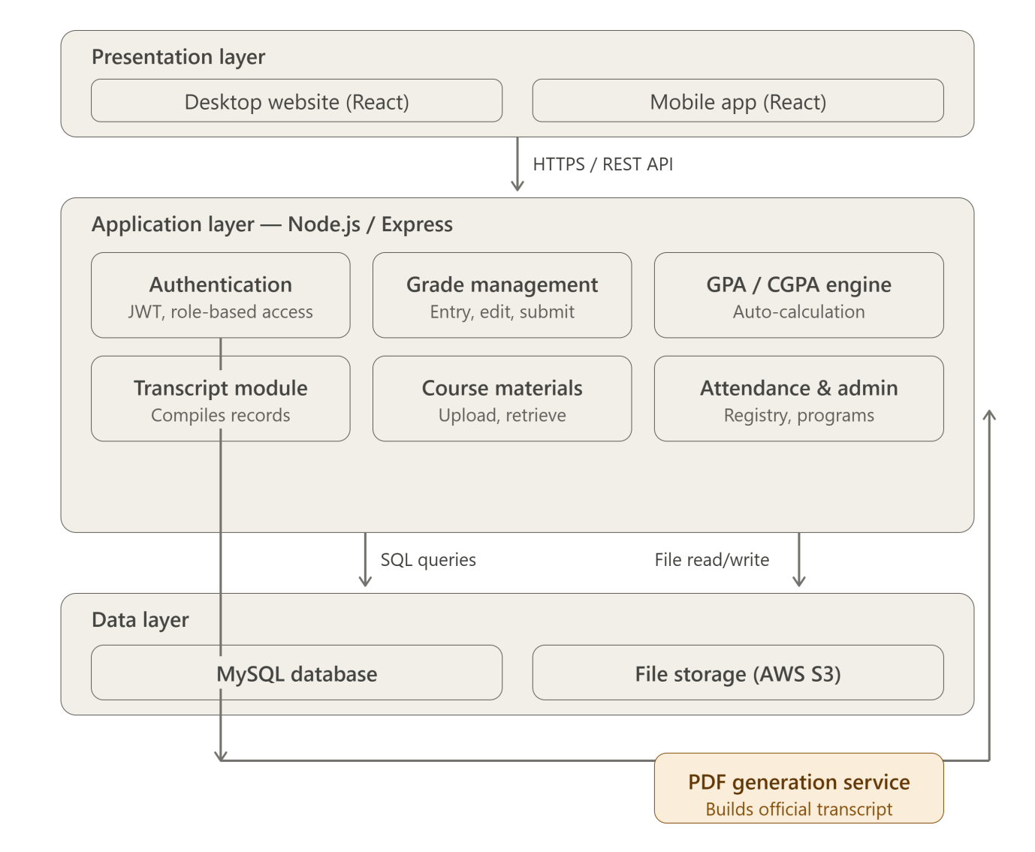

3.4 Technology Stack
Layer | Technology | Purpose
Frontend | React.js, HTML5, CSS3, Tailwind CSS | User interface and interaction
Backend | Node.js, Express.js | API logic, authentication, GPA calculation
Database | MySQL | Storing students, courses, grades, semesters
PDF Generation | PDFKit / Puppeteer | Generating official transcript PDFs
File Storage | AWS S3 / Cloudinary | Storing lecture materials and transcripts
Authentication | JWT (JSON Web Tokens) | Secure role-based session management
Version Control | Git & GitHub | Source code management and collaboration
Deployment | Render / DigitalOcean | Cloud hosting and CI/CD pipeline

3.5 UML Diagrams

3.5.1 Use Case Diagram Description
The Use Case Diagram for Limko Wi Skul captures all interactions between the four user roles and the system. Key use cases include:
- Student: Login, View Grades, View GPA/CGPA, Download Transcript, Download Course Materials, View Attendance.
- Lecturer: Login, Enter Grades, Edit Grades, Submit Grades for Approval, Upload Course Materials, Mark Attendance.
- Registry (Admin): Login, Review Submitted Grades, Approve Transcripts, Manage Student Records, Manage Courses and Semesters.
- Dean/HOD: Login, View Department Reports, View Lecturer Submission Status, View Student Performance Analytics.
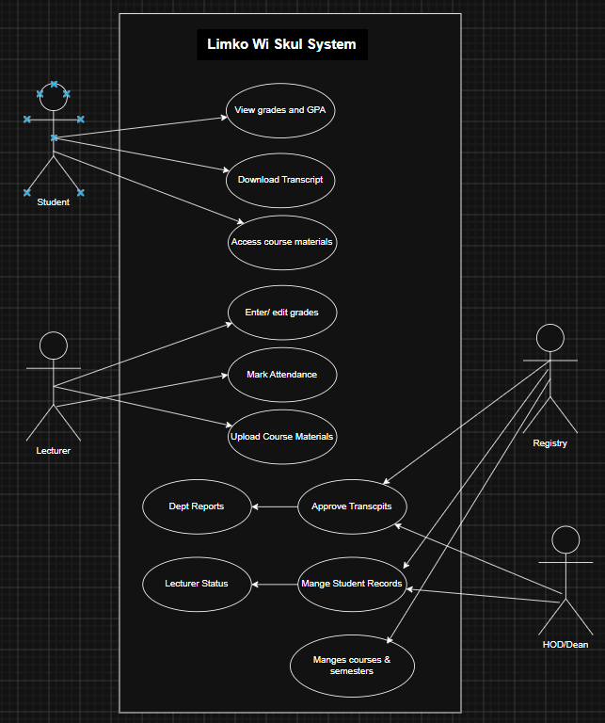

3.5.2 Class Diagram Description
The Class Diagram defines the main entities of Limko Wi Skul and their relationships:
- User (base class): userID, name, email, password, role — inherited by Student, Lecturer, Registry, Dean.
- Student: studentID, programID, level, enrollmentDate (extends User).
- Course: courseID, title, creditHours, lecturerID, semesterID.
- Grade: gradeID, studentID, courseID, semesterID, score, gradeLetter, gradePoint, status (pending/approved).
- Semester: semesterID, name, academicYear, startDate, endDate.
- Transcript: transcriptID, studentID, generatedDate, cgpa, fileURL.
- CourseMaterial: materialID, courseID, title, fileURL, uploadDate.
- Attendance: attendanceID, studentID, courseID, date, status (present/absent).
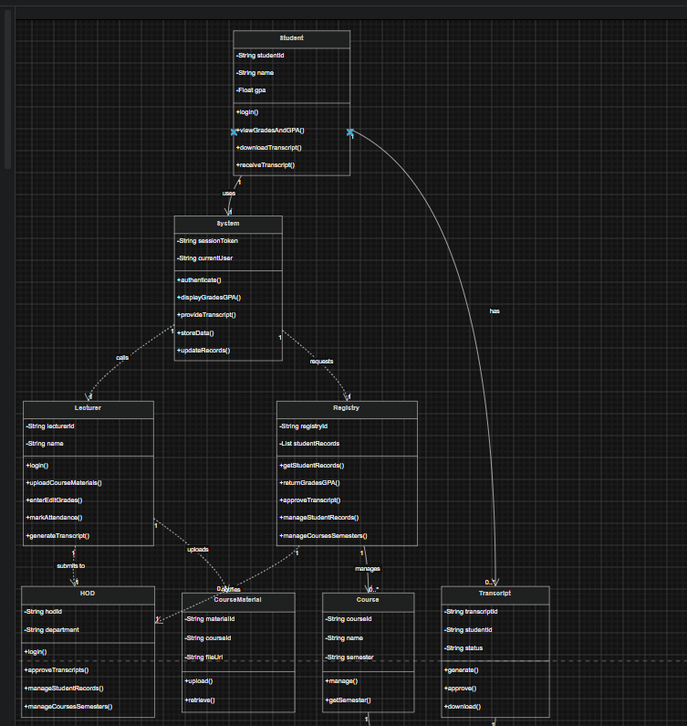

3.5.3 Sequence Diagram Description
A Sequence Diagram is provided for the 'Generate Transcript' flow:
- Student navigates to the Transcript page and clicks 'Download Transcript'.
- Frontend sends a GET /transcript/:studentID request to the backend.
- Backend queries MySQL for all approved grades across all semesters for that student.
- Backend calculates the cumulative CGPA using the GPA Calculation Engine.
- Backend passes the compiled data to the PDF Generation Service, which formats it using the official transcript template.
- Backend returns the generated PDF file to the frontend, which triggers a download for thestudent.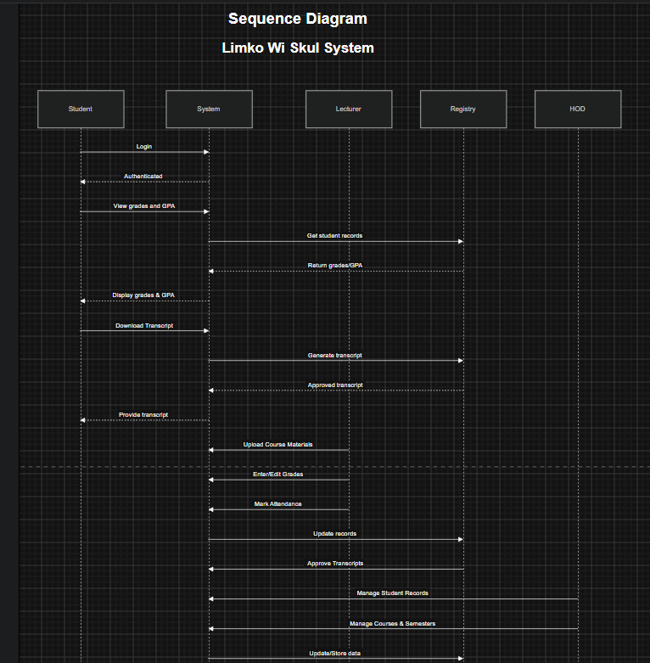

4. Prototype Development (UI/UX)

4.1 Design Tool
The Limko Wi Skul prototype is designed using Figma, a professional cloud-based UI/UX design tool. Figma was selected because it supports real-time collaboration, interactive prototyping, and component reuse — making it ideal for designing a multi-role academic portal with distinct dashboards for students, lecturers, registry staff, and deans.

4.2 Design Principles
The following UI/UX design principles guide the Limko Wi Skul prototype:
- Clarity: Academic data such as grades, GPA, and attendance must be presented clearly and unambiguously, since this data has serious consequences for students.
- Consistency: A unified color palette (dark navy #14213D, green #1D9E75, blue #378ADD, white background) and typography (Poppins font) are used throughout.
- Trust and Officialness: The transcript view and download screens are designed to look formal and official, mirroring a real university transcript layout.
- Responsive Design: Student-facing screens are optimized for mobile, while lecturer, registry, and dean screens are optimized for desktop given their data-entry-heavy nature.
- Feedback: The system provides clear visual confirmation for actions such as grade submission, approval, and successful transcript generation.

4.3 Key Screens (Minimum 10)
The following twelve screens form the core prototype of Limko Wi Skul:
# | Screen Name | Key Elements
1 | Splash / Welcome Screen | Limko Wi Skul logo, tagline 'Awi Skul, Awi Rezult', Login button
2 | Login Screen | University ID/email and password fields, role selector, login button
3 | Student Dashboard | Welcome banner, current GPA, enrolled courses, recent grade updates, quick links to transcript
4 | Student Grades & GPA View | Per-course grades table for selected semester, semester GPA, cumulative CGPA chart
5 | Time Table | To present exam schedules in chronological order,to help students prepare and manage exam schedules effectively.
6 | Notice Screen | Centralises official communication from Registry, lecturers, and the Dean's office so no student misses important information.
7 | Notifications | Surfaces real-time, personal alerts distinct from general announcements.
8 | Student Profile | Displays the student's personal and academic identity information and provides access to account-level actions.
9 | Settings | Allows students to control notification preferences, privacy settings, and basic account options.
10 | Take Attendance | Allows lecturers to efficiently record student attendance for a specific class session.

Note: All 10 screens are designed and linked in Figma as a Mockup prototype. The Figma link is included in the GitHub repository README.
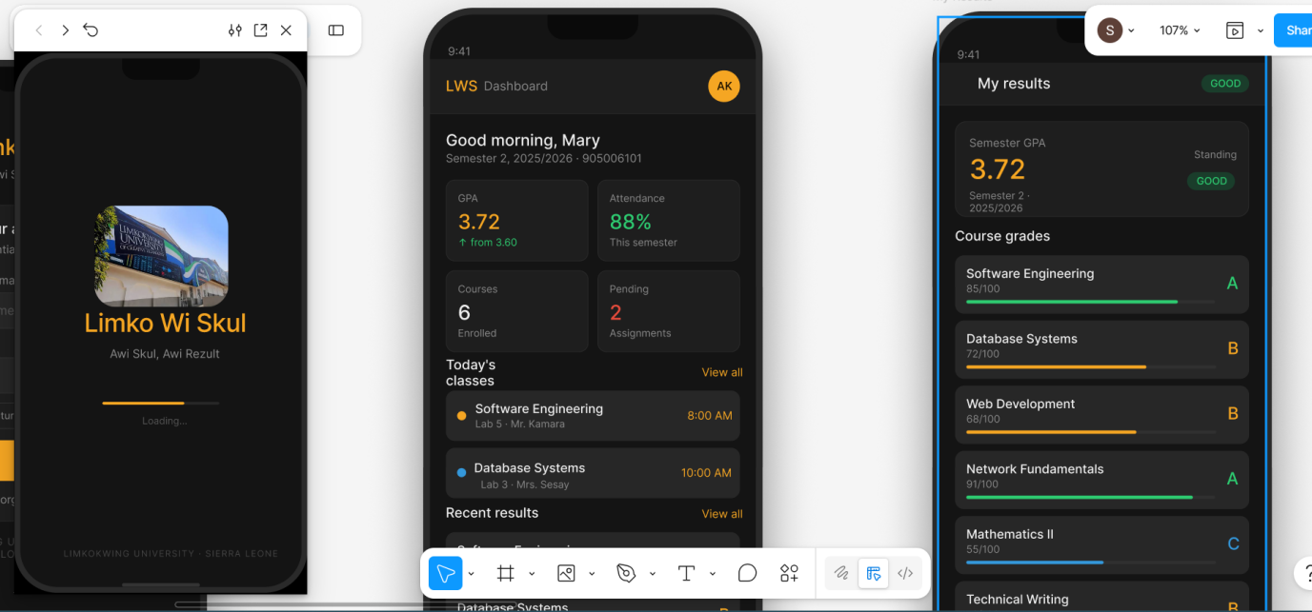

5. Git & GitHub Integration

5.1 Repository Setup
A public GitHub repository has been created for Limko Wi Skul to host all project files, enable version control, and support collaborative development. The repository is organized into a clear folder structure.

5.2 Repository Structure
The repository is organized as follows:
- /docs — Project report (PDF), architecture diagram, and UML diagrams.
- /prototype — Figma export files, screen screenshots, and prototype link.
- /src — Source code for frontend and backend modules.
- /database — MySQL schema file (schema.sql) covering students, courses, grades, semesters, and seed data.
- /planning — Gantt chart, network diagram, and project plan documents.
- README.md — Project overview, setup instructions, Figma link, and contributors.
- LICENSE — MIT License file.

5.3 Version Control Practices
The following Git workflow is followed throughout the project:
- Main Branch (main): Contains stable, reviewed code only.
- Development Branch (develop): Active development work is merged here before going to main.
- Feature Branches: Each new feature is developed in a separate branch (e.g., feature/grade-entry, feature/transcript-pdf).
- Commit Messages: Follow the convention: [type]: description (e.g., feat: add GPA calculation engine, fix: transcript PDF layout bug).
- Pull Requests: All code changes are reviewed via Pull Requests before merging.

5.4 Collaboration
GitHub Issues are used to track bugs and feature requests, such as 'Fix CGPA rounding error' or 'Add semester filter to transcript view'. The GitHub Projects board provides a Kanban-style view of task progress (To Do, In Progress, Done). All team members commit regularly to demonstrate active collaboration.

6. Project Management Plan

6.1 Gantt Chart
The Gantt chart below outlines the planned schedule for the Limko Wi Skul project from Week 4 to Week 11. Tasks are organized by SDLC phase and each task is assigned a duration within the project timeline.
Task | W4 | W5 | W6 | W7 | W8 | W9 | W10 | W11
Planning & Requirements | ■ | ■
System Design & Architecture |  | ■ | ■
Figma Prototype Design |  | ■ | ■ | ■
Sprint 1: Authentication Module |  |  | ■ | ■
Sprint 2: Grade Management Module |  |  |  | ■ | ■
Sprint 3: GPA/CGPA Engine & Dashboard |  |  |  |  | ■ | ■
Sprint 4: Transcript Generation Module |  |  |  |  |  | ■ | ■
Sprint 5: Materials, Attendance & Admin |  |  |  |  |  |  | ■ | ■
Testing & UAT |  |  |  |  |  | ■ | ■
Documentation & Report |  | ■ | ■ | ■ | ■ | ■ | ■ | ■
GitHub & Deployment |  |  |  |  |  |  | ■ | ■
Final Submission |  |  |  |  |  |  |  | ■

Legend: Shaded cells (■) indicate active work during that week.

6.2 Network Diagram (Critical Path Method)
The Network Diagram uses the Critical Path Method (CPM) to identify the sequence of dependent tasks that determine the minimum project duration. The diagram is drawn as a directed acyclic graph (Activity on Node format).
Key activities and their dependencies are:
ID | Activity | Duration (days) | Predecessor | ES-EF
A | Project Planning & Requirements | 7 | — | 0–7
B | System & Architecture Design | 7 | A | 7–14
C | Figma Prototype Design | 14 | B | 14–28
D | Sprint 1: Authentication | 7 | B | 14–21
E | Sprint 2: Grade Management | 7 | D | 21–28
F | Sprint 3: GPA/CGPA Engine | 7 | E | 28–35
G | Sprint 4: Transcript Generation | 7 | F | 35–42
H | Sprint 5: Materials & Admin | 7 | G | 42–49
I | Testing & UAT | 7 | F, G, H | 49–56
J | GitHub & Deployment | 5 | I | 56–61
K | Documentation & Submission | 3 | J | 61–64

Critical Path: A → B → D → E → F → G → H → I → J → K (Total: 64 days)
The critical path identifies tasks that cannot be delayed without extending the overall project deadline. Of particular note, Sprint 4 (Transcript Generation Module) sits on the critical path, reflecting its importance as the core deliverable of the system — any delay here directly impacts the Week 11 submission deadline.

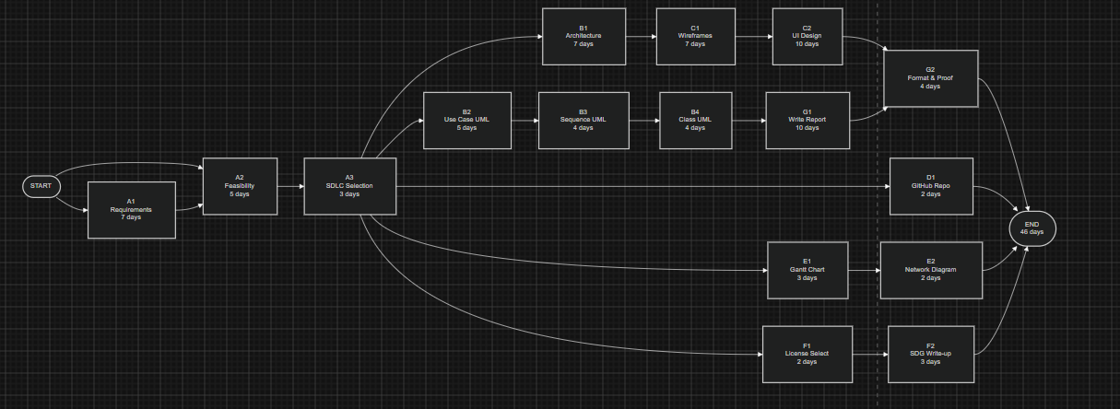

7. License, Design Quality & SDG Relevance

7.1 Software License
Limko Wi Skul is released under the MIT License, one of the most permissive open-source licenses available. The MIT License was chosen for the following reasons:
- It allows Limkokwing University, and potentially other tertiary institutions in Sierra Leone, to freely use, copy, modify, and distribute the software for their own academic record management needs.
- It is compatible with the Digital Public Goods Standard, which requires that a system be open source and freely available.
- It is simple and concise, making it easy for university administrators to understand the terms of use and adoption.

License Header (included in all source files):
MIT License | Copyright (c) 2026 Limko Wi Skul Contributors | Permission is hereby granted, free of charge, to any person obtaining a copy of this software...

All external libraries and frameworks used (React.js, Express.js, Tailwind CSS, MySQL, PDF generation libraries) are also open-source and their licenses (MIT, Apache 2.0) are clearly acknowledged in the project's LICENSE.md file and README.

7.2 Design Quality (UI/UX)
The Limko Wi Skul user interface is designed following established UX principles and best practices to ensure a clean, professional, and trustworthy experience appropriate for an academic records system:
- Visual Consistency: A defined design system (color palette, typography, spacing, button styles) is applied uniformly across all 12 screens, ensuring lecturers and students always recognize the system regardless of which role-based dashboard they are using.
- Navigation: A persistent sidebar (desktop, for lecturer/registry/dean roles) and bottom navigation bar (mobile, for student role) ensures users can always reach core features within two clicks or taps.
- Typography: Poppins font is used for its high readability on both academic data tables and the transcript layout. Heading sizes follow a clear hierarchy (H1: 24px, H2: 18px, Body: 14px).
- Color Palette: Dark Navy (#14213D) for headers and primary structure, Green (#1D9E75) for positive states and confirmations, Blue (#378ADD) for informational elements and links, with a white background for clarity. All color combinations pass WCAG 2.1 AA contrast requirements.
- Data Integrity Cues: Grade entry screens use clear validation states — green for saved/approved, amber for pending approval, red for rejected or flagged entries.
- Official Transcript Styling: The transcript view screen mirrors the layout and formality of a real Limkokwing University transcript, including university letterhead placement, to build trust in the digital document.

7.3 SDG Relevance and Impact
Limko Wi Skul directly advances United Nations Sustainable Development Goal 4: Quality Education, and contributes to SDG 9: Industry, Innovation and Infrastructure. The table below maps specific system features to relevant SDG targets:
SDG Target | System Feature | Expected Impact
4.3 – Equal access to tertiary education | Real-time digital access to grades, GPA, and transcripts for all students | Reduces delays and inequities in accessing official academic records
4.4 – Relevant skills for employment | Digital portal used daily by students, lecturers, and staff | Builds digital literacy across the university community
9.c – Increase access to ICT | Replaces paper-based transcript compilation with a digital system | Modernizes core academic infrastructure at the university
4.7 – Education for sustainable development | Reduces paper usage for transcripts and printed results | Supports more sustainable, environmentally-conscious university operations
9.5 – Enhance technological capabilities | Open-source codebase available for adoption by other institutions | Enables other Sierra Leonean universities to adopt similar digital systems

Beyond its direct SDG alignment, Limko Wi Skul also reduces the administrative burden on Limkokwing University's academic registry, freeing staff time for higher-value student support activities, and gives students immediate confidence in the accuracy and availability of their academic records — particularly important when applying for scholarships, transfers, or employment that require urgent transcript submission.

8. Documentation & Conclusion

8.1 Report Structure
This report has been prepared according to the submission guidelines specified in the PROG 102 Final Project Brief. It is formatted using Tahoma font at 12pt, 1.5 line spacing, with justified alignment. All sections are clearly numbered and diagrams (architecture, UML, Gantt chart, network diagram) are included within the relevant sections.
Supporting files — including the Figma prototype link, GitHub repository link, source code, and UML diagram files — are all submitted as part of the project package and referenced in the GitHub repository README.

8.2 Challenges and Limitations
During the design and planning of Limko Wi Skul, the following challenges were identified:
- Data Migration: Existing student academic records at Limkokwing University are stored in various formats (spreadsheets, paper files). Migrating this historical data into the new system's database will require careful validation to avoid errors in cumulative CGPA calculations.
- Change Management: Lecturers accustomed to submitting grades manually may require training and encouragement to adopt the new digital grade entry process. The system addresses this through a simple, guided grade entry interface.
- Transcript Authenticity: Digital transcripts must be trusted by external parties such as employers and other institutions. Future versions could incorporate digital signatures or QR-code verification to confirm transcript authenticity.

8.3 Future Enhancements
The following features are planned for future versions of Limko Wi Skul:
- Version 2.0: Online course registration module, allowing students to register for courses each semester directly through the portal.
- Version 3.0: QR-code or digital signature verification on transcripts for authenticity checks by external parties.
- Version 4.0: Integration with a learning management component for online quizzes and assignment submission, expanding beyond grade and transcript management.

8.4 Conclusion
Limko Wi Skul represents a practical and achievable contribution to modernizing academic record management at Limkokwing University of Creative Technology, Sierra Leone. By replacing manual, paper-based grade compilation and transcript printing with a centralized digital portal, the system directly reduces administrative workload for lecturers and the academic registry, while giving students real-time, transparent access to their academic performance.
The project demonstrates a comprehensive application of software engineering principles, from the selection of an appropriate SDLC model (Agile/Scrum), through system architecture design, UML modeling, UI/UX prototyping, and project management planning. The open-source MIT License ensures that Limko Wi Skul remains a true Digital Public Good — freely available, adaptable, and capable of being adopted by other tertiary institutions across Sierra Leone facing the same challenges.
Submitted in partial fulfillment of the requirements for PROG 102 – Principles of Software Engineering, Limkokwing University of Creative Technology, Sierra Leone.

9. References
Agile Alliance. (2023). Agile Manifesto and Principles. Retrieved from https://agilemanifesto.org
Atlassian. (2024). What is Scrum? Retrieved from https://www.atlassian.com/agile/scrum
Digital Public Goods Alliance. (2024). Digital Public Goods Standard. Retrieved from https://digitalpublicgoods.net/standard
Limkokwing University of Creative Technology. (2026). PROG 102 – Principles of Software Engineering Final Project Brief. Freetown: Limkokwing University.
Open Source Initiative. (2024). MIT License. Retrieved from https://opensource.org/licenses/MIT
React.js Documentation. (2024). Getting Started with React. Retrieved from https://react.dev
Sommerville, I. (2016). Software Engineering (10th ed.). Pearson Education.
United Nations. (2015). Transforming Our World: The 2030 Agenda for Sustainable Development. New York: United Nations.
United Nations Development Programme. (2024). Sustainable Development Goal 4: Quality Education. Retrieved from https://sdgs.un.org/goals/goal4
United Nations Development Programme. (2024). Sustainable Development Goal 9: Industry, Innovation and Infrastructure. Retrieved from https://sdgs.un.org/goals/goal9

